MAKEREREUNIVERSITY

**COLLEGE OF COMPUTING AND INFORMATICS TECHNOLOGY**

**A NEWS APP**

By

GROUP 25

**DEPARTMENT OF COMPUTER SCIENCE**

**SCHOOL OF COMPUTING AND INFORMATICS TECHNOLOGY**

**GROUP MEMBERSHIP**

|  |  |  |  |
| --- | --- | --- | --- |
| **SN0** | **Registration**  **Number** | **Student**  **Number** | **Name** |
| 1 | 19/U/16083/EVE | 1900716083 | AKANKWASA IVAN |
| 2 | 19/U/16450/PS | 1900716450 | JADWONG GILBERT |
| 3 | 19/U/16574/PS | 1900716574 | KATONGOLE FATIHI |
| 4 | 19/U/2233/EVE | 1900722333 | ONYANGO MOSES EVANS |

**INTRODUCTION**

We came up with the news app which shows both local news and international news.

**BACKGROUND**

People usually start their mornings by checking on their phones for the weather forecasts and the recent news in the country and also internationally most especially when they have a working day or a trip scheduled. Especially when it goes to farming and other fields dependent of weather conditions. Nowadays businesses need a constant flow of information about their market and competitors to stay informed and make better decisions and also to monitor their businesses. Therefore instead of opening two apps one for news another one for weather forecast, we combined all of them in one application.

**DESIGN DECISIONS TAKEN.**

We used React JS to develop our app and also implemented the news API and the weather API.

**React JS**

React JS is a free and open source front-end JavaScript library for building user interfaces based on UI components.

**Why React JS?**

**Readability**

It can easily be read and understood since it has a small set of primitive constructs which can be combined in a relatively small number of ways to to build the control and data structures of the language.

**Writability**

It can easily be used to programs since it provides amazing developer tools and also easy to adopt.

**Reliability**

It is conformance to specifications since it handles dependencies and also extremely competent.

**Cost**

It is cost efficient since it requires less skills to use, software creation is not expensive, the execution and compilation time are very fast and finally it is cheap to maintain.

**News API**

Here we used the news catcher api which provide both the local and global news trending at that moment and this api is free for month .

**Weather API**

The weather API allows you to access recent weather data including daily weather forecasts, wind speed and direction, precipitation number, and other weather alerts. This helps people using the app to know when and how to do a certain activity as far as the weather is concerned which help clients/users to create deeper insights into the process of optimizing business process, reducing costs, and taking advantage of additional revenue opportunities.

**Benefits of using the weather API**

* Data is processed and displayed fast in the app
* Cost effective. Working with it will save you a lot of money in case you will heed the weather forecast.

**News API**

A news API is either used as a data source, to build your product, to collect information or just to aggregate data.

**HOW THE APP WORKS**

To start the app you run npm start opens up the server at port 3000 in the bowser.

**The news page**

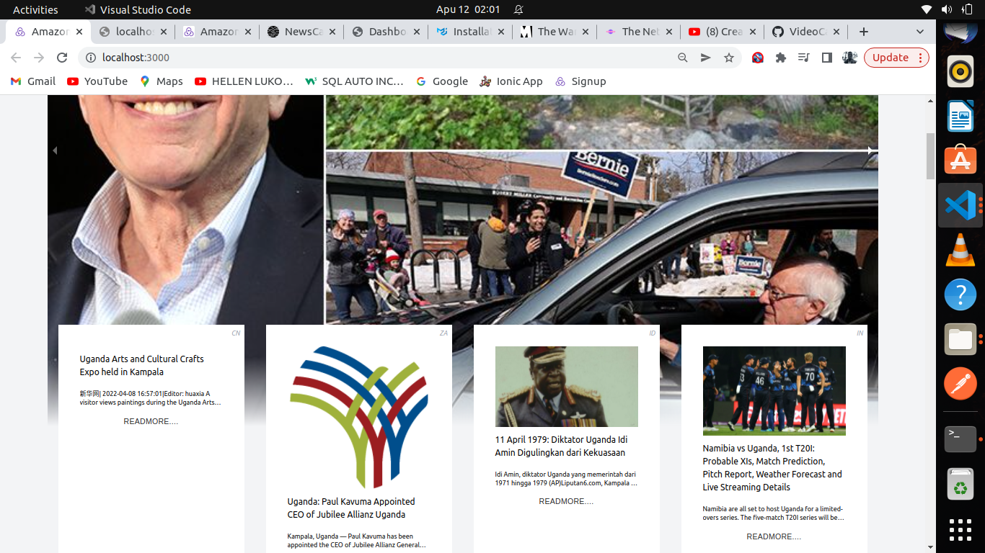

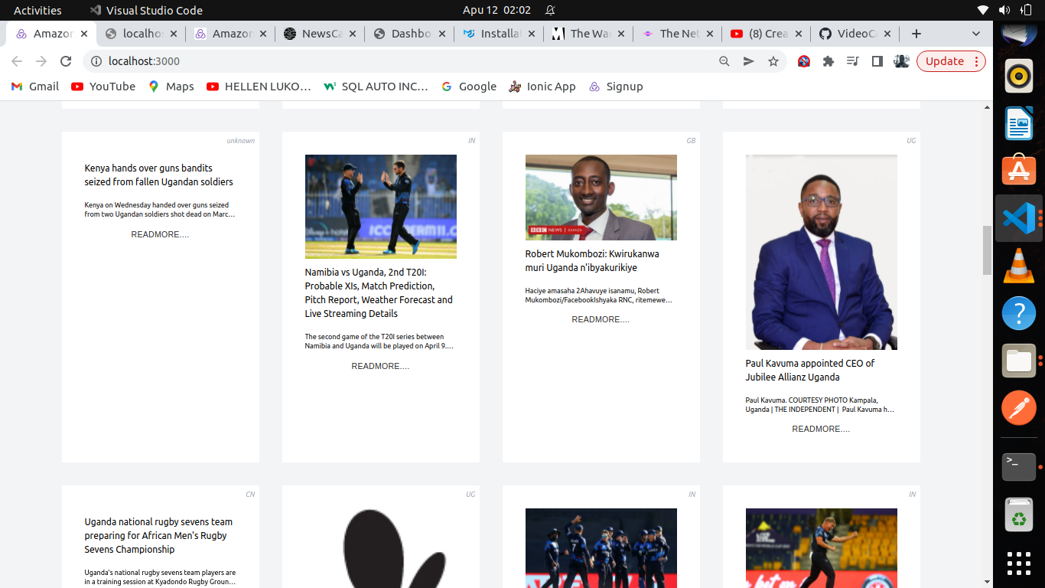

**Weather forecast page**

There at a weather page you put your current city and country as shown in the picture there

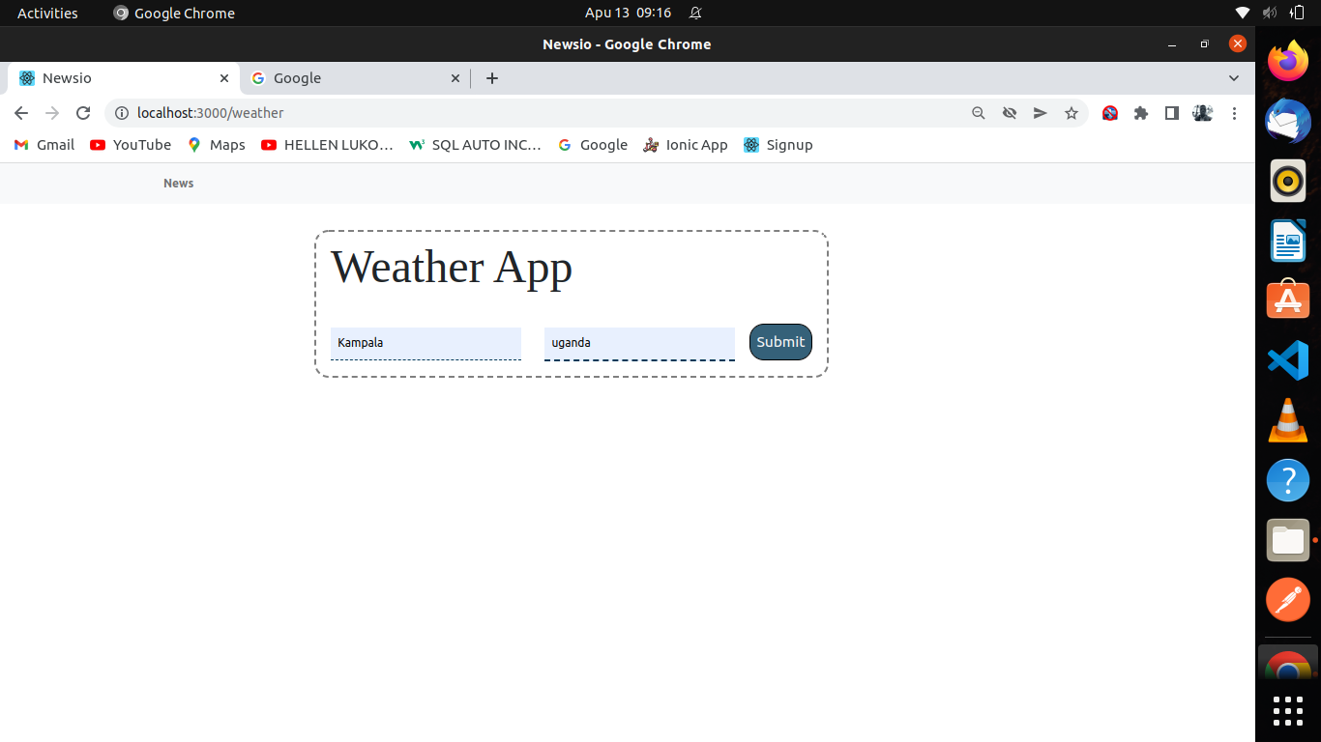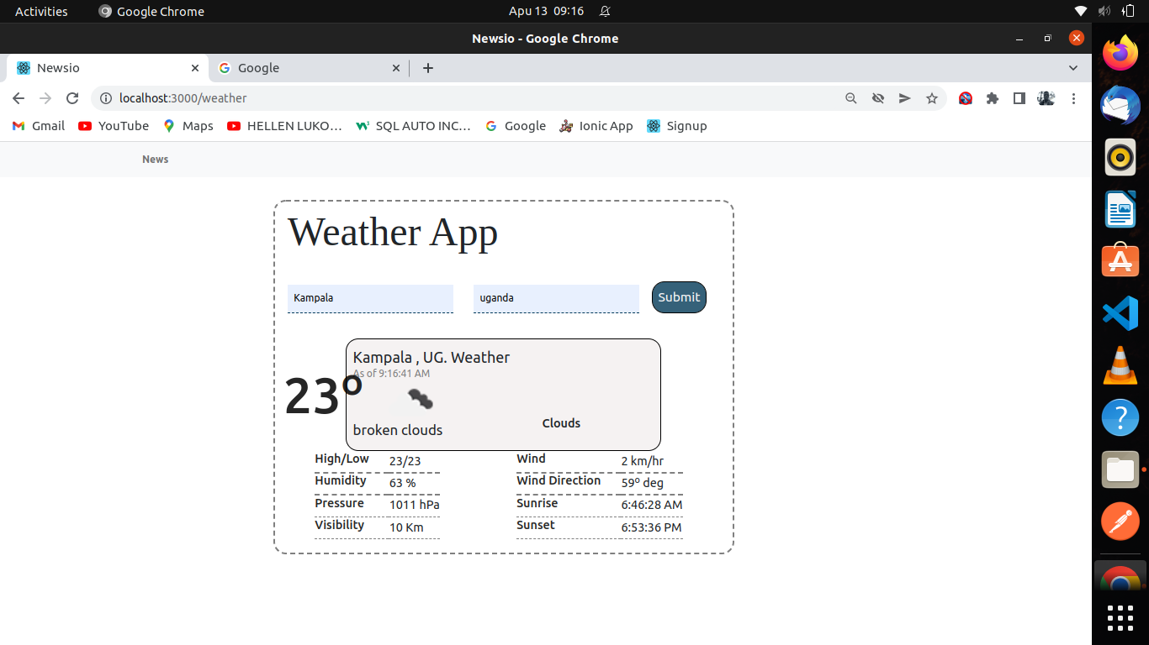

**The line to the GitHub responsory :**

**https://github.com/akankankwasa-navi/News_weather_app**

**References**

[http://en.m.wikipedia.org](http://en.m.wikipedia.org/)

http://www.clariontech.com